11 - Chapin – I Feel Lucky
Original key: B Us: same

Plan
Intro: 4 bars guitar, 4 bars band
Verse 1: no piano lick yet
Chorus 1: 4 bars B at end
Instrumental: 4 bars riff
Verse 2, Chorus 2
Instrumental Chorus
Verse 3: (band punches every 2nd bar)
Chorus 3, TWICE
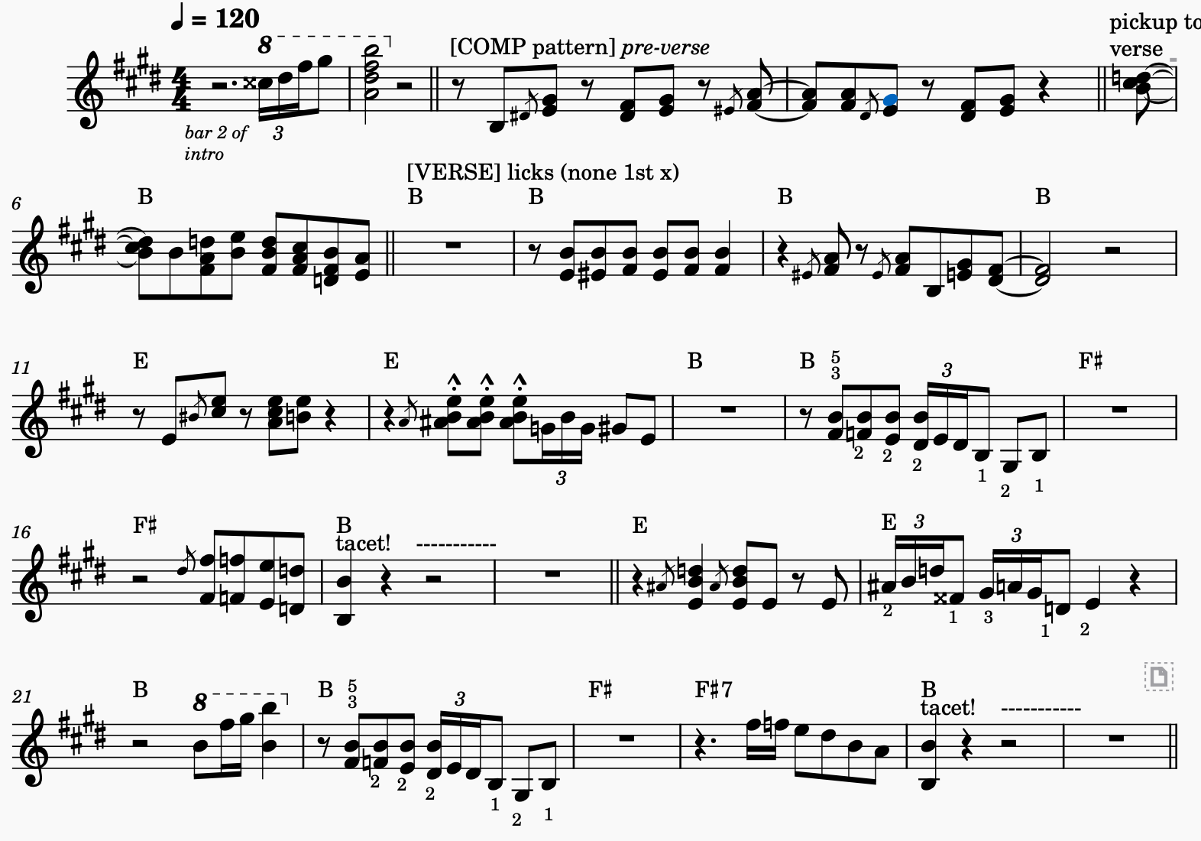
Verse 4: piano solo
end

